BIA (Boston Institute of Analytics)
Batch: Data science, AI, ML (Feb - june)
Name: Apeksha kashyap
Topic: Stellar Object Classification
Submission date: 26 june 2025
Project duration: 15th june – 26th june

ABSTRACT

This project focuses on the classification of celestial objects—stars, galaxies, and quasars (QSOs)—using supervised machine learning algorithms. Leveraging a publicly available astronomical dataset containing photometric and spectral features such as u, g, r, i, z magnitudes, redshift, and positional coordinates (alpha, delta), the objective is to automate the classification process and improve the accuracy and efficiency of astronomical cataloging.
The dataset was preprocessed through outlier removal, feature scaling, and label encoding. A total of seven machine learning models were developed and evaluated: Decision Tree, Random Forest, K-Nearest Neighbors, Support Vector Machine (SVM), AdaBoost, Gradient Boosting, and XGBoost.
This study not only improves the automation of celestial object classification but also offers valuable insights into feature importance and model performance in an astronomical context.

🔭 INTRODUCTION

The classification of celestial objects such as stars, galaxies, and quasars is a fundamental task in modern astronomy. Accurate classification not only contributes to the construction of astronomical catalogs but also aids in understanding the structure and evolution of the universe. Traditionally, this classification process has relied on manual analysis of spectral and photometric data by astronomers — a time-consuming and subjective approach, especially given the massive scale of current and upcoming sky surveys.
With the advent of data-intensive telescopes and missions like the Sloan Digital Sky Survey (SDSS), astronomical datasets have grown to include millions of objects. This has necessitated the use of automated, scalable techniques to classify objects efficiently. Machine learning (ML) offers a promising solution by enabling systems to learn from labeled datasets and predict the classes of unseen celestial objects with high accuracy.
This project applies several supervised machine learning algorithms to classify celestial bodies into three main categories: stars, galaxies, and quasars (QSOs). Using a dataset composed of key astrophysical features such as photometric magnitudes (u, g, r, i, z), celestial coordinates (alpha, delta), and redshift, we evaluate and compare the performance of multiple models. These include Decision Tree, Random Forest, K-Nearest Neighbors, Support Vector Machine (SVM), AdaBoost, Gradient Boosting, and XGBoost.
The goal is to build robust, generalizable models that can automate classification with high accuracy, reduce human bias, and provide insight into the most informative features influencing classification. The outcome of this project has potential applications in astronomical research pipelines, aiding in the rapid analysis of future large-scale survey data.

DATASET OVERVIEW

- Dataset Name: star_classification.csv
- Source: (Sloan Digital Sky Survey), provided by BIA
- Target Variable: Class i.e. Star, Galaxy, QSO
- Features Used:
  - Photometric: u, g, r, i, z
  - Positional: alpha, delta
  - Spectral: redshift
- Dataset Size: 1,00,000 rows × 18 features/columns

DATA PREPROCESSING

    - Imported csv file in the jupyter notebook

    - Null values:
The dataset was first examined to check if any null values were present. It was confirmed that no null values were present, ensuring that the dataset was complete and ready for numerical operations.

    - Label Encoding:
Checked for datatypes of all the columns, the target column “class” originally consisting of string labels were encoded to numeric values.
Encoded class as numeric values (Star=1, Galaxy=2, Quasar=3)

    - Removing irrelevant features:
Segregates the target column, and the features that were to necessary to predict that column, and dropped all the other columns which were not useful for prediction. That led to 8 columns being the most relevant for prediction.

    - Handled outliers (removed rows with value -9999):
After EDA it was observed that spme of the features had outlier values like
-9999, which was interfering with retrieving proper insights. After confirming that there was only one value per column that had outliers, it was decided to drop that particular row. Hence handling the outlier.

    - Split Testing and Training data:
Split data into two section, 80% for training and 20% for testing.
Used Stratify to make sure that there was consistent data split in both the sections.

    - Feature Scaling using StandardScaler and RobustScaler:
- StandardScaler: Applied to most numeric features (u, g, r, i, z, alpha, delta) to transform them to a standard normal distribution (mean = 0, std = 1).
- RobustScaler: Applied specifically to the redshift column due to the presence of outliers. RobustScaler scales data based on the interquartile range, which is less sensitive to extreme values.

EXPLORATORY DATA ANALYSIS (EDA)
    - Used boxplots and histograms to study distribution of features:
- Upon generating the initial boxplots, it was observed that certain features contained undetected outliers, which distorted the visual interpretation of their distributions. These outliers had not been identified earlier, resulting in misleading boxplot representations. After properly handling the outliers (e.g., removing invalid values such as -9999), the boxplots were re-plotted, providing a more accurate and insightful visualization of the feature distributions. The corrected plots are shown below.:

    - u-band Magnitude
- Similar pattern as g, but with a more noticeable difference between galaxies and stars.
- Stars show lower magnitudes; QSOs are spread wider.
- Insight: Helpful in separating stars from QSOs and galaxies.

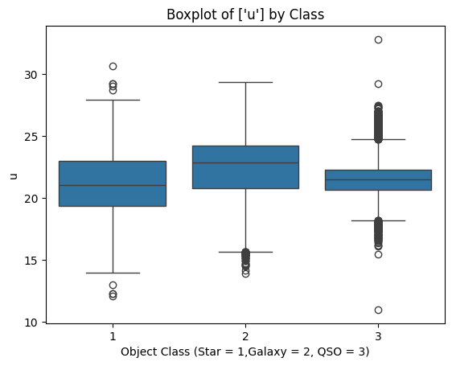
    - g-band Magnitude
- QSOs exhibit more variance with higher magnitude values.
- Galaxies and stars overlap significantly, though stars generally show slightly lower values.
- Insight: Might help with QSO classification, but not sufficient alone.

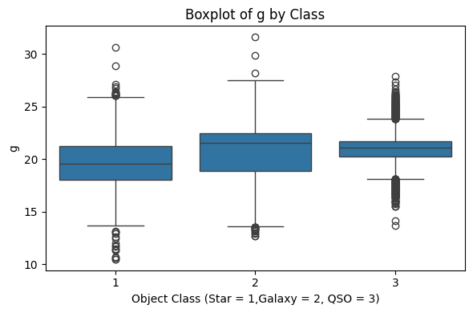

    - r-band Magnitude
- Displays noticeable spread across all three classes.
- QSOs have higher magnitudes than stars.
- Some outliers are visible but not extreme.
- Insight: Adds moderate discriminative value, especially in distinguishing QSOs from stars.

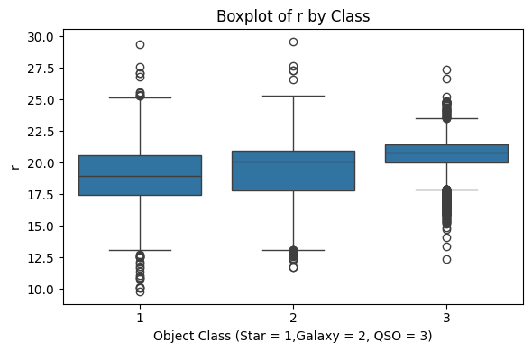

    - i-band Magnitude
- Stars tend to have lower magnitudes (brighter), and QSOs show slightly higher values.
- Shows moderate overlap between classes.
- Insight: Possibly a supporting feature, not primary for separation.

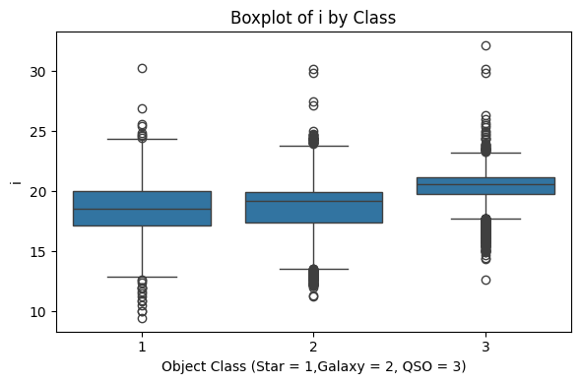

    - z-band Magnitude
- QSOs (3) exhibit slightly higher magnitudes (dimmer objects), while stars (1) are slightly more concentrated at lower magnitudes.
- Outliers are present in all three classes.
- Insight: Some overlap exists; not a strongly distinguishing feature on its own but may add value when combined with others.

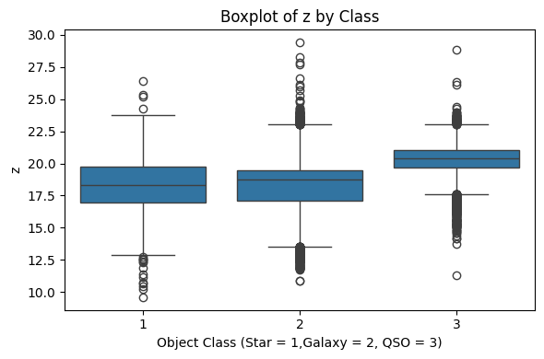

    - Redshift
- Stars (1): Very low redshift (~0), tightly clustered.
- Galaxies (2): Moderate redshift, wider spread than stars.
- QSOs (3): Very high redshift with a long tail of outliers — typical of distant quasars.
- Insight: Redshift is a highly discriminative feature and plays a key role in classification.

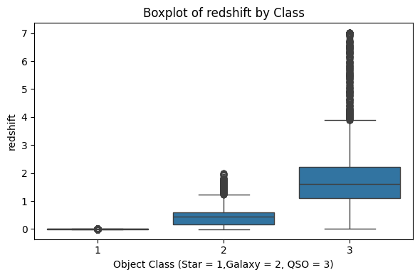

2. Feature correaltion chart:

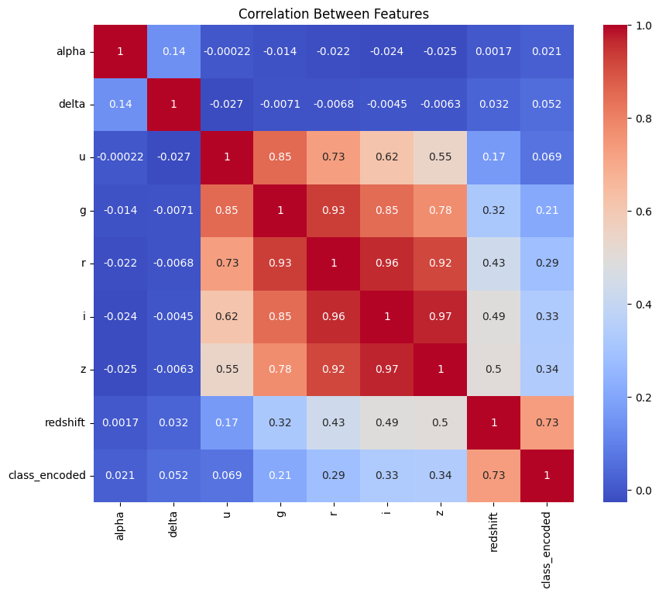

MODEL TRAINING AND EVALUATION

Model | Accuracy
- Decision Tree | 97.3%
- Random Forest | 97.6%
- K-Nearest Neighbors | 94.4%
- Support Vector Machine (RBF) | 96.4%
- Gradient Boosting | 97.6%
- AdaBoost | 90.4%
- XGBoost | 97.2%
To accurately classify celestial objects, several supervised machine learning models were trained and evaluated. The models were tested using key metrics such as accuracy, precision, recall, and F1-score. Confusion matrices provided insight into class-wise performance, and hyperparameter tuning (via GridSearchCV) was applied to enhance model efficiency and reduce overfitting.
Below is the result of every trained model and their accuracy result:

Evaluation Metrics:
- Accuracy, Precision, Recall, F1-Score
- Confusion Matrices for all models
Hyperparameter Tuning:
- GridSearchCV applied on Random Forest

CONCLUSION

This project demonstrates the successful application of machine learning for the multiclass classification of celestial objects—specifically stars, galaxies, and quasars (QSOs)—using structured photometric, spatial, and spectral data. A total of seven supervised learning models were trained and evaluated to determine their effectiveness in automating astronomical object classification.
Among the models tested, Random Forest and Gradient Boosting achieved the highest accuracy of 97.6%, closely followed by XGBoost at 97.2% and Support Vector Machine (SVM) at 96.4%. Decision Tree performed well with 97.0% accuracy, while K-Nearest Neighbors scored 94.2%, and AdaBoost trailed with 90.0%, highlighting its limitations for complex multiclass problems.
The findings highlight the strength of ensemble learning methods in handling high-dimensional, multiclass data effectively. Additionally, the project reinforces the importance of thorough data preprocessing, including outlier removal, feature scaling, and label encoding, all of which played a crucial role in achieving high model performance.
For future work, the classification task could be extended by incorporating deep learning approaches, such as convolutional neural networks for image-based inputs or transformer-based models for spectroscopic analysis. These advancements would further enhance accuracy and scalability in astronomical classification, supporting the data demands of modern sky surveys.

References
- Scikit-learn documentation
- XGBoost documentation
- https://matplotlib.org/stable/users/index
- AI assistant

